### ID 27378

**Software Development Life Cycle (SDLC)**

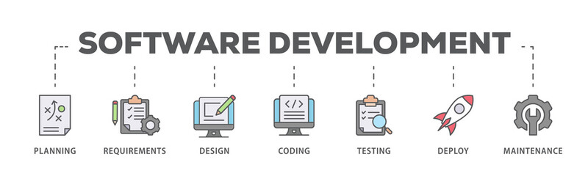

**1. Planning:**

Self Explain: Before even talking to the future homeowners in detail (like in the initial "Analysis" I described), the planning phase is like deciding if and how to build the house in the first place. This involves defining the scope of the project: What exactly are we trying to achieve? What are the goals? What are the available resources (budget, team, time)? We also assess potential risks and create a high-level plan outlining the different stages of the project, the timelines, and the responsibilities of everyone involved. It's about setting the overall strategy and roadmap for the entire software development effort.

**2. Analysis (or Requirements Gathering):**

Self Explain: Now, with the initial plan in place, the analysis phase is where you have those detailed conversations with the clients (the future software users). You delve deep into their needs, wants, and expectations for the software. What problems are they trying to solve? What specific features do they require? You document these requirements meticulously, ensuring clarity and agreement among all stakeholders about what the software will do.

**3. Design:**

Self Explain: Once you understand what needs to be built (from the analysis phase), the design phase is like creating the detailed blueprints for the house. This involves outlining the architecture of the software.

**4. IMPLEMENTATION:**

Architects create detailed plans, including the structure, layout, and aesthetics of the house. In software, this means designing the user interface (how it looks and feels), the database (where the information is stored), and the overall architecture of the system.

**Development (or Coding):** This is where the construction crew (the developers) build the house according to the blueprints. They write the actual code that makes the software function as designed. Different programming languages and tools are used to bring the software to life.

**5. Testing:**

Self Explain: Once the basic structure of the house is built, you need to inspect it thoroughly to ensure everything is working correctly and safely. This is the testing phase. Testers rigorously examine the software to identify any bugs, errors, or defects. They check if all the features work as expected, if the software is stable and reliable, and if it meets the requirements defined in the analysis phase. Different types of testing are performed, like functional testing (checking if features work), usability testing (checking if it's easy to use), and performance testing (checking if it can handle the expected load).

**6. Maintenance:**

Self Explain: Even after the house is built and the owners move in, it requires ongoing maintenance to keep it in good condition. This includes regular cleaning, repairs, and upgrades. Similarly, the maintenance phase in software development starts after the software has been deployed and is being used by end-users. It involves fixing any bugs that are discovered after release, providing updates with new features or improvements, and ensuring the software continues to run smoothly and meets the evolving needs of the users. This phase can last for the entire lifespan of the software.

So, in essence, these phases represent a structured approach to building and maintaining software, ensuring that the final product is effective, reliable, and meets the users' needs.